* **@JoinColumns**

Sử dụng khi muốn Join nhiều field

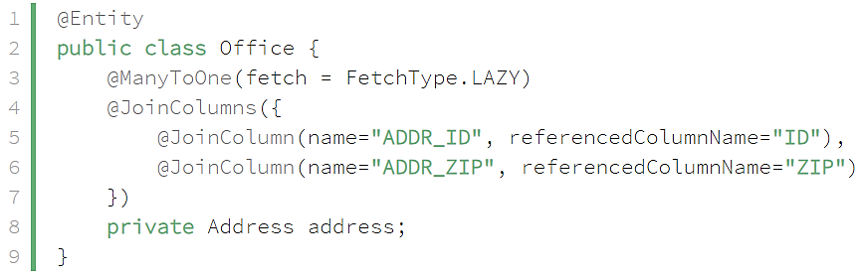

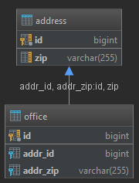

* **Reference**

<https://www.baeldung.com/jpa-join-column>